**Activity based**

**Project Report on**

**Computer Networks**

**Submitted to Vishwakarma University, Pune**

**Under the Initiative of**

**Contemporary Curriculum, Pedagogy, and Practice (C2P2)**

**By**

**Arun Adhikari**

**SRN No : 202100406**

**Roll No : 38**

**Div : G**

**Third Year Engineering**

**Department of Computer Engineering**

**Faculty of Science and Technology**

**Academic Year**

**2023-2024**

**Project Statement :**

Design and implement a Local Area Network (LAN) for a specified location, such as a school, office building, or community center.

**Problem Description :**

Design and implement a Local Area Network (LAN) for a specified location, such as a school, office building, or community center. The project involves identifying optimal spots for network devices (switches, routers, and access points), configuring the network with appropriate IP addresses, establishing communication between different sub-networks, and calculating the overall cost of network development. This project aims to provide students with hands-on experience in network design, configuration, and cost analysis.

**Project Modules:**

**Theory:**

**1.1 Local Area Network (LAN):** A Local Area Network (LAN) is a group of interconnected devices that share a common communication line within a specific geographical area, like a building or campus. It allows devices to share resources such as files, printers, and internet access.

**1.2 Components of LAN:**

* **Routers**:  
  Routers are networking devices that direct data packets between networks. They serve as a gateway that routes data traffic between local area networks (LANs) and wide area networks (WANs). A router uses the IP address of the destination to forward data across networks.

**Key Router Functions**:

* + Routing data between subnets and the external internet.
  + Assigning IP addresses using Dynamic Host Configuration Protocol (DHCP).
  + Implementing Network Address Translation (NAT) to allow internal devices to access external networks with a single public IP address.
* **Switches**:  
  Switches are critical devices used to connect multiple devices within a LAN. They operate at the Data Link layer of the OSI model and forward data based on MAC addresses. Unlike routers, switches do not route data between networks but within the same network segment.

**Types of Switches**:

* + **Managed Switches**: These allow for more control over the network and can handle tasks such as VLAN creation and traffic prioritization.
  + **Unmanaged Switches**: These are simpler switches that do not provide customization options but are easy to install and configure.
* **Wireless Access Points (WAPs)**:  
  WAPs allow wireless devices like laptops, smartphones, and tablets to connect to the LAN. These are essential for providing internet access in areas where wired connections are impractical or for enabling mobile connectivity.

**Types of Access Points**:

* + **Standalone Access Points**: Simple devices that create a single wireless network.
  + **Controller-based Access Points**: Used in large networks, these are centrally managed for better control and scalability.

**1.3 IP Addressing and Subnetting:** Every device on a network needs a unique IP address to communicate with other devices. IP addressing follows the IPv4 (32-bit) or IPv6 (128-bit) protocol. Subnetting divides a network into smaller sub-networks, which helps in managing IP addresses more efficiently and controlling traffic.

* **Subnet Mask**: A subnet mask is a 32-bit number that divides an IP address into network and host portions. Subnetting helps reduce the number of devices in a single broadcast domain, improving network performance and security.

**Example of Subnetting**:

* + IP Address: 192.168.1.0
  + Subnet Mask: 255.255.255.0
  + Subnetting divides this into multiple subnets, e.g., 192.168.1.0/24 and 192.168.2.0/24, allowing efficient address allocation and management.

**1.4 VLANs (Virtual LANs):** VLANs are used to divide a single physical network into multiple logical networks. This can help to:

* Improve network security by isolating sensitive data.
* Reduce broadcast traffic, increasing performance.
* Simplify management by grouping users according to functions (e.g., Admin, Student, Guest).

**1.5 Network Design Considerations:** When designing a LAN, the following factors need to be considered:

* **Network Size**: Number of users and devices that will be connected.
* **Scalability**: The ability to expand the network as needed in the future.
* **Redundancy**: Ensuring failover mechanisms, such as using multiple switches or access points to avoid single points of failure.
* **Bandwidth**: Capacity to handle the expected network traffic, including peak loads.

**1.6 Cost Estimation:** The overall cost of a network setup depends on the number of devices (routers, switches, access points), cabling, installation labor, and future maintenance. Enterprise-grade devices are more expensive but offer better performance and longevity.

**Implementation :**

**Step-by-Step Procedure:**

1. **Survey the Location:**
   * Identify the dimensions of the location (school, office building, community center) and mark out where key network components should be placed (e.g., server room, access points).
2. **Determine Device Requirements:**
   * Calculate the number of switches, routers, and access points needed based on the area and number of users.
   * Determine cable requirements (e.g., CAT5e or CAT6) based on distance between devices.
3. **Network Design Layout:**
   * Create a diagram of the network using tools like Cisco Packet Tracer or Microsoft Visio. Ensure switches are positioned strategically to minimize cable length and optimize coverage for access points.
4. **IP Address Allocation:**
   * Assign a private IP range (e.g., 192.168.x.x) and create subnets based on different departments or floors (if designing for a school or office).
   * Example:
     + Admin Subnet: 192.168.1.0/24
     + Student Subnet: 192.168.2.0/24
     + Guest Wi-Fi Subnet: 192.168.3.0/24
5. **Configuration of Devices:**
   * Configure routers and switches with appropriate IP addresses, gateways, and routing protocols.
   * Configure VLANs to segregate network traffic.
   * Set up Wireless Access Points (WAPs) for Wi-Fi coverage and assign SSIDs (e.g., "School-WiFi" for students, "Admin-WiFi" for staff).
6. **Testing:**
   * Test connectivity between subnets using ping commands.
   * Verify internet access for all devices connected to the network.
   * Ensure proper functioning of switches and access points.

1. **Quantity:**

|  |  |  |
| --- | --- | --- |
| DEVICE | QUANTITY | COST |
| Routers | 36 | 1200 |
| Switches | 6 | 16000 |
| Ethernet Cables (Cat6) | 460m | 11/meter |
| Camera | 54 | 1400 |

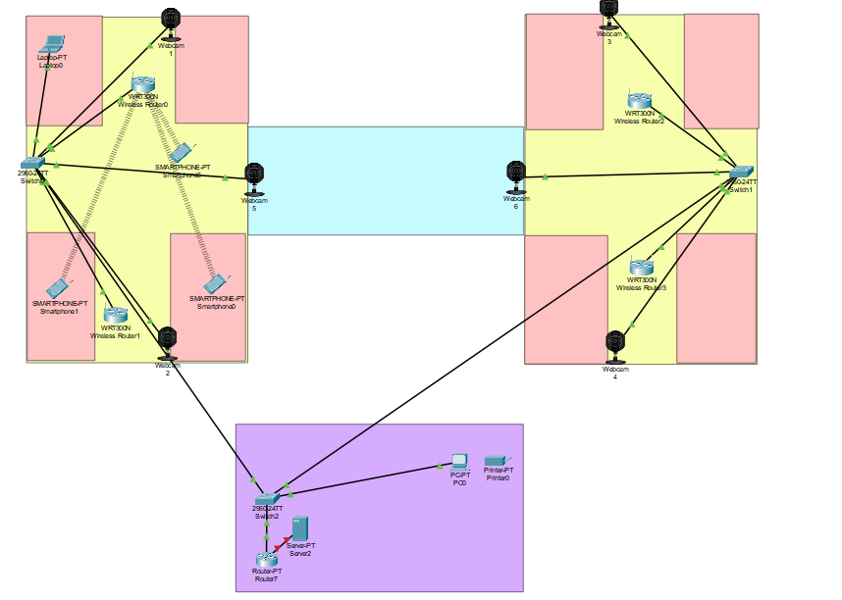

**Code:**

### 1. ****Ping****

Used to test the connectivity between your device and another device (e.g., a server or another computer) on the network by sending ICMP Echo Requests.

**Ping 192.168.1.1**

### ****Traceroute****

Displays the route that packets take to reach a destination by listing each hop along the path. It helps to identify where delays are occurring.

**tracert www.google.com**

### 3. ****Ipconfig (Windows) / Ifconfig (Linux)****

Displays the current network configuration, including IP address, subnet mask, and default gateway of your device.

**ipconfig /all**

### 4. ****Netstat****

Displays network connections, routing tables, interface statistics, and more. It’s useful for diagnosing network issues or viewing active connections.

**netstat -an**

### 5. ****Nslookup****

Used to query Domain Name System (DNS) to obtain domain name or IP address mapping. It helps troubleshoot DNS issues.

nslookup google.com

**Output:**

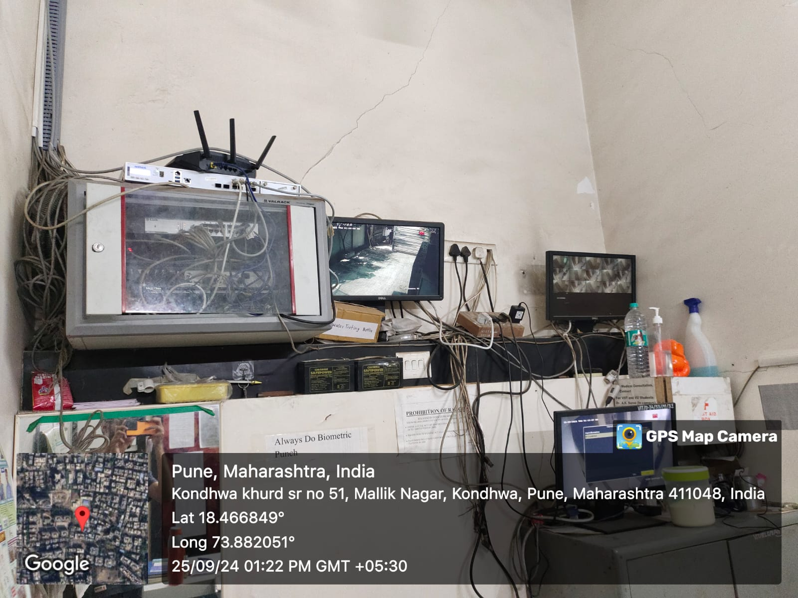

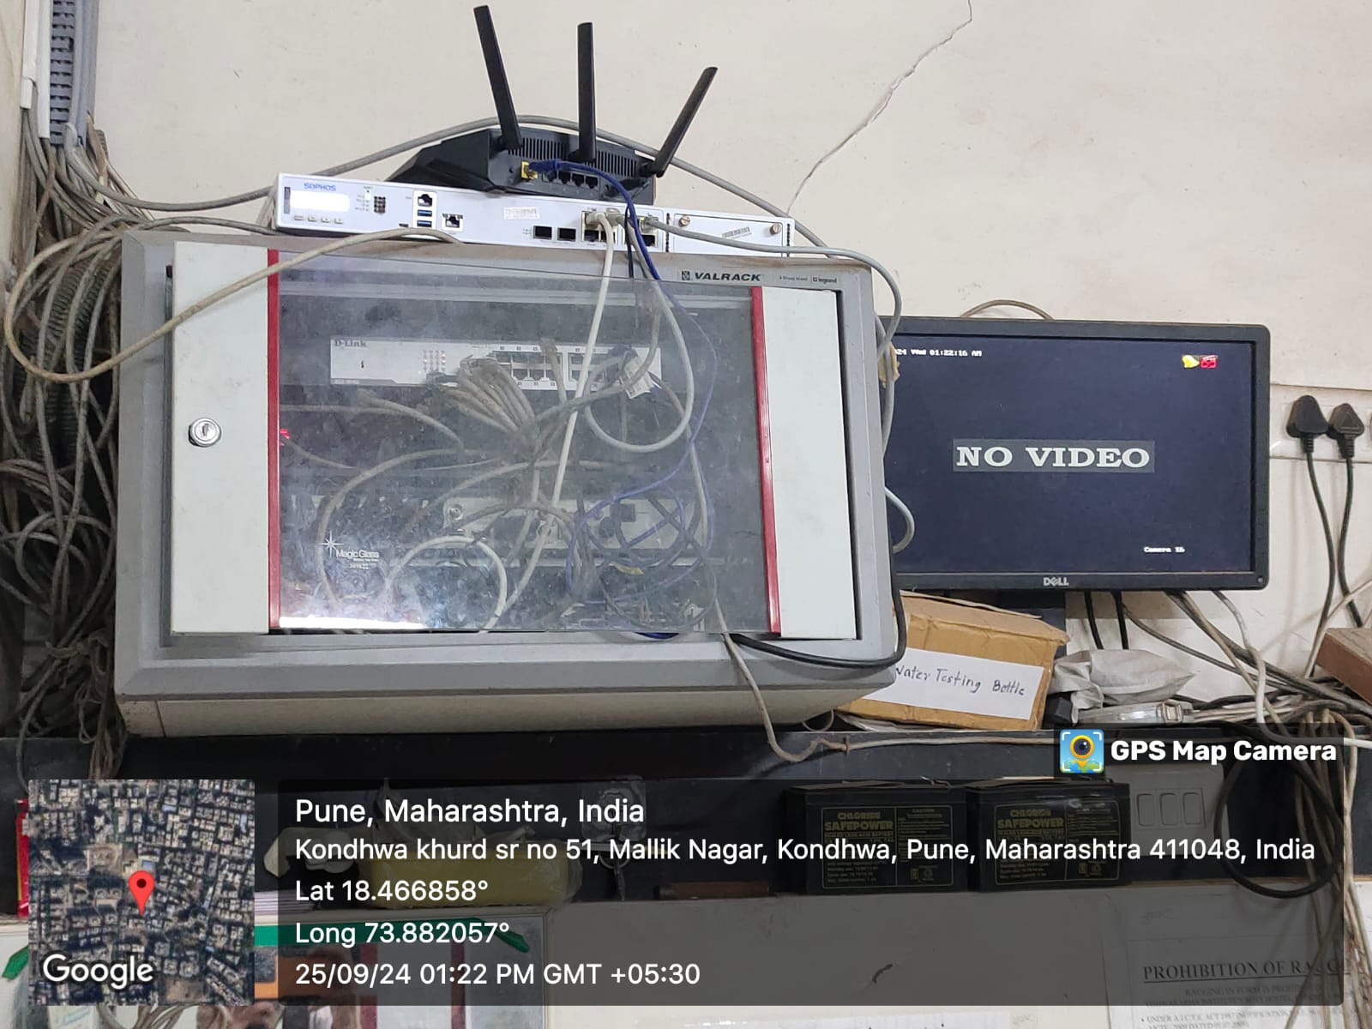

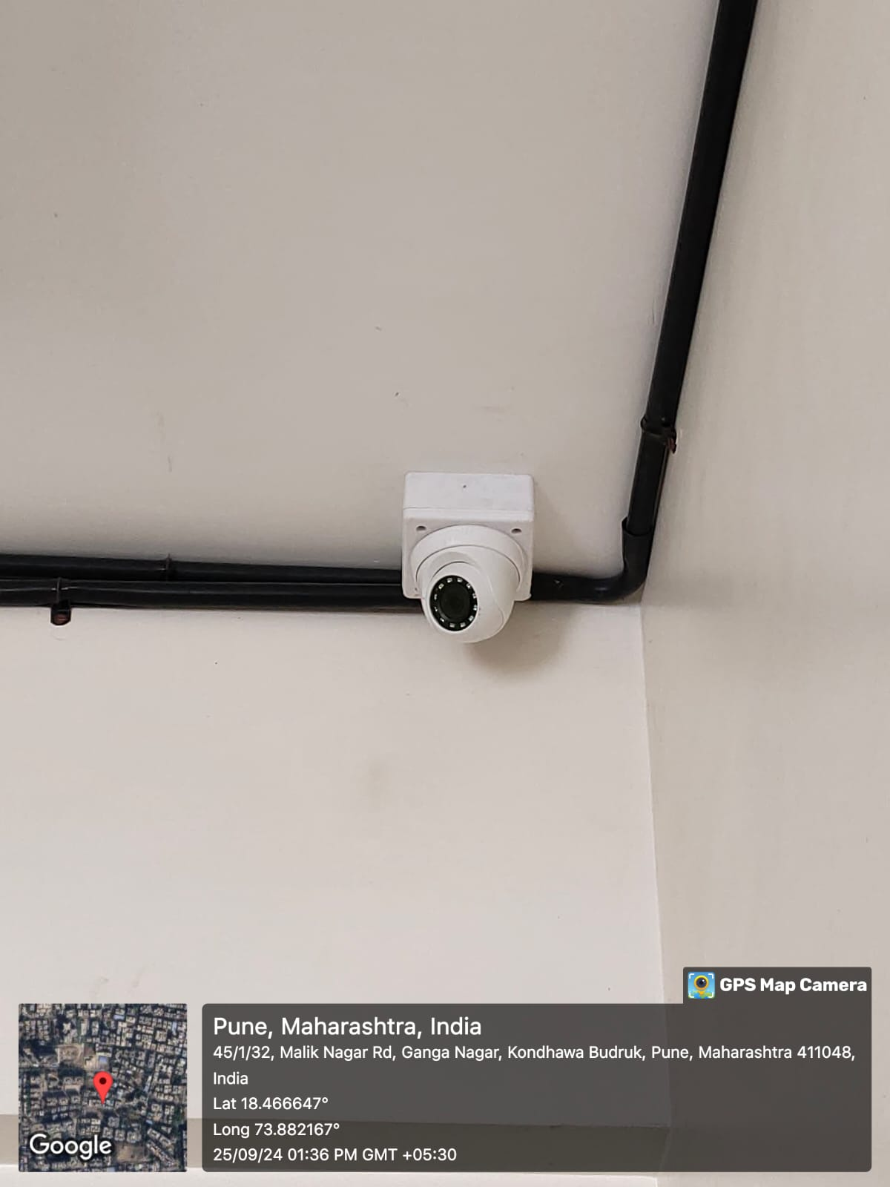

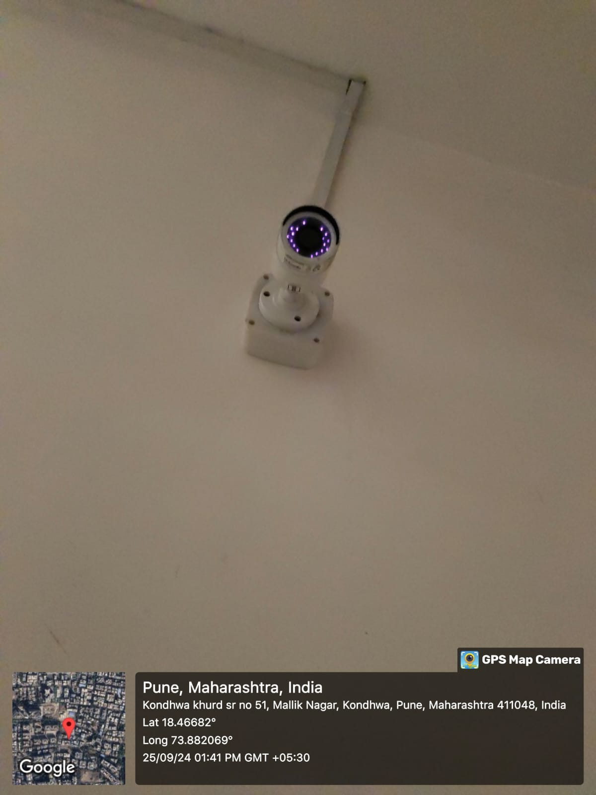

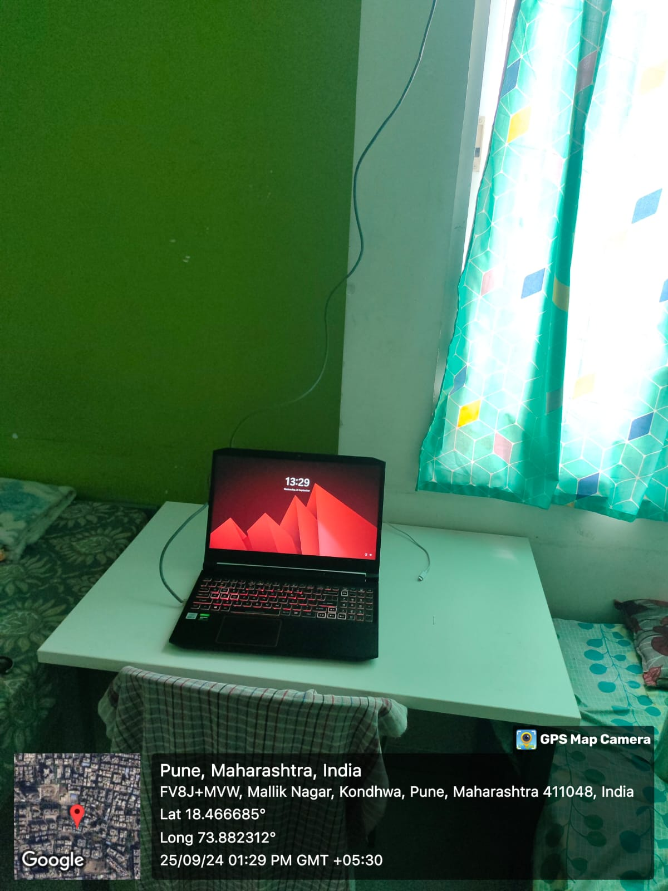

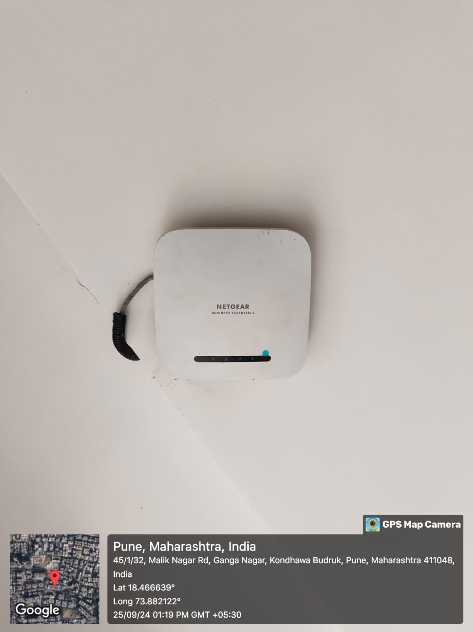

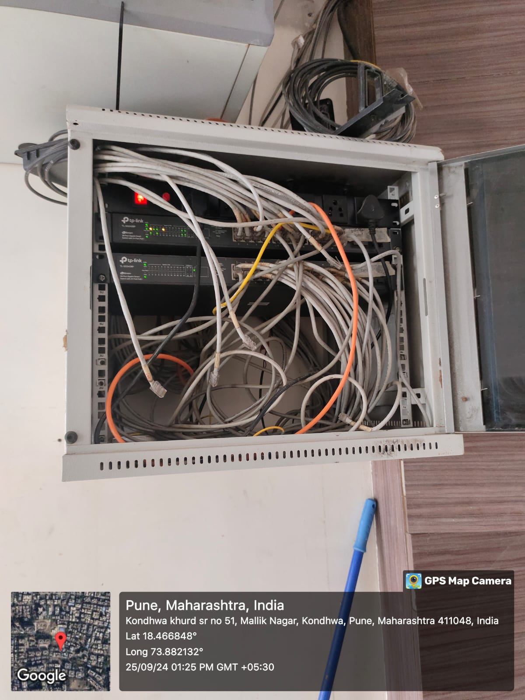

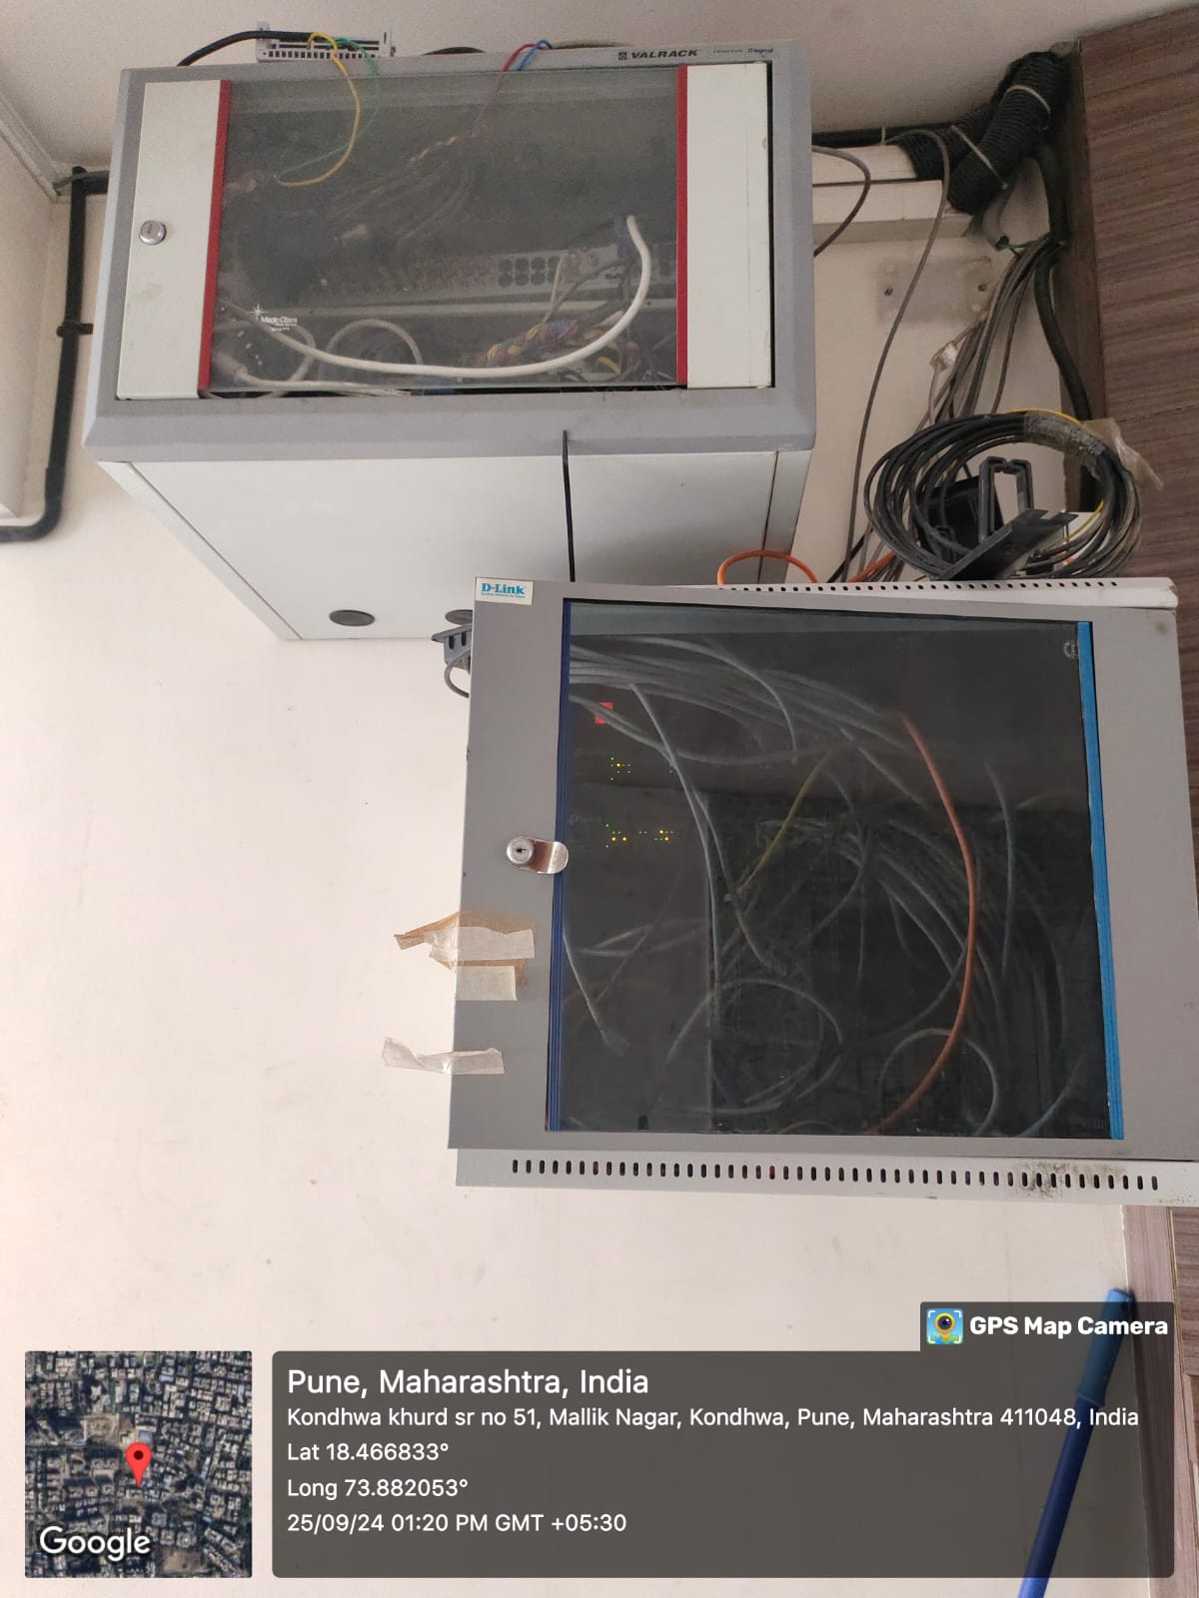

**Conclusion :**

This project demonstrates the full process of designing and implementing a LAN for a specific location. It provides insight into network configuration, IP addressing, VLAN setup, and the installation of physical components. The cost estimation ensures the network is both efficient and cost-effective. This practical experience will help build an understanding of how to manage real-world network setups.